Assignment Name: | Country | 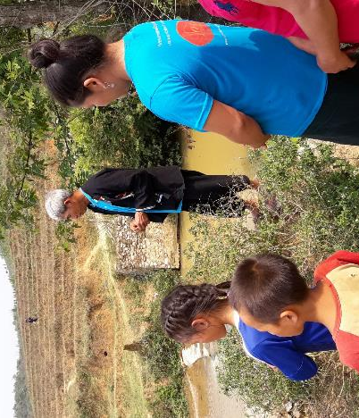  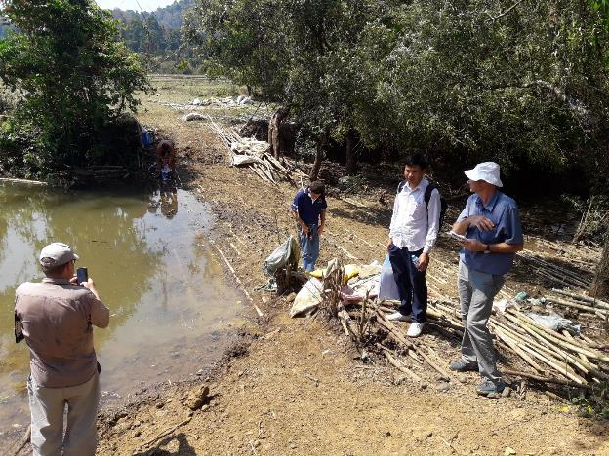
TA-9323 LAO: Sustainable Rural Infrastructure and Watershed Management Project – and Flood and Drought - Transaction Technical Assistance (TRTA) Firm (50236-001) | Lao PDR
Location Within Country: Luanprabang, Huaphan, Xieng Khouang, Sayabouli | Professional Staff Provided by CES
Water resources
Fish passage
Gender
Social safeguards
Finance
Environment
Value chains
Irrigation engineering
Climate change
Agri farming systems
GIS

Name of Client | No. of Staff
Asian Development Bank | 11
Start date (Mth/Yr) Completion date (Mth/Yr) | No. of Staff Months
21 December 2017 to October 2022 | 150
Name of Senior Staff | Approx. Value of Services
Sengkham INTHIRATVONGSY | $600,000
Brief Description of project:
Sustainable Rural Infrastructure and Watershed Management Sector Project (LAO 50236). The proposed Project will increase the profitability of the agriculture, natural resources and rural development sector to be aligned with the following impact: sustainable and inclusive rural development achieved. Its outcome will be sustainable, market oriented agricultural production and natural resources management in selected watersheds enhanced. The project has three outputs:
(i) productive rural infrastructure (PRI) upgraded to be climate resilient, efficient, and sustainable;
(ii) land use management within the PRI scheme watersheds improved; and
(iii) Institutional arrangements and capacity for good agriculture practices and sustainable watershed management improved.
Detailed description of Actual Services Provided by Company Personnel
Project preparation. Assist international engineers to undertake irrigation and access road survey and design, and carry through to detailed engineering designs for 4 subprojects in Xieng Khouang, Sayabouli, Luangprabang and Huaphan provinces benefitting some 30 villages. Undertake feasibility studies of selected subprojects and undertake social safeguard due diligence and prepare project RRP and all linked documents. Feasibility assessment includes agriculture development, environment, resettlement, ethnic minorities, gender, PPP, economic, fish migration mitigation, water user group status. Prepare the ensuing project. Define the scope, cost, procedures for identifying subprojects, financing plan, implementation arrangements, procurement, technology issues, capacity development, maintenance arrangements, and adherence to ADB safeguard policies. It will also provide advance action support to enhance project readiness, as well as to ensure that PRI is designed in a climate change resilient manner.

